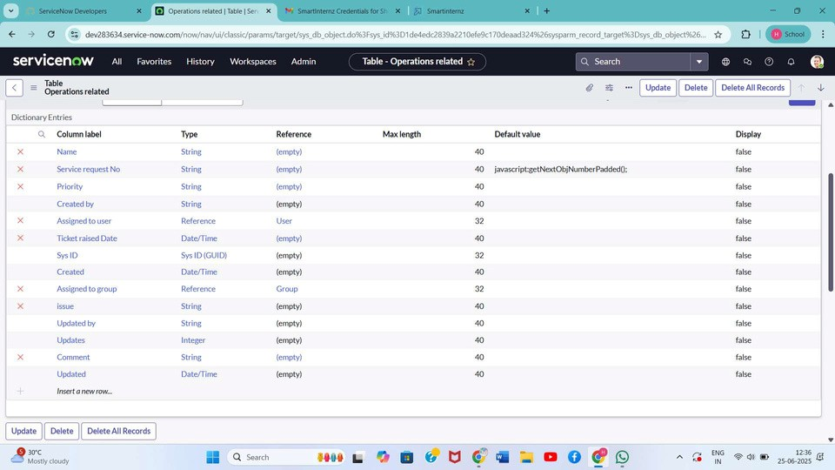

Performance Testing

Date

Team ID

Project Name

Maximum Marks

Model Performance Testing:

06

2025

sep

NM2025TMID13007

Streamlining Ticket Assignment for Efficient Support

Operations

2

Marks

:

1

. Data Rendered

The Operations Related table in ServiceNow is populated with multiple support tickets. These records

include different issue types such as 'Unable to login', '404 Error', and 'Regarding Certificates'. This

confirms that data is being recorded and rendered accurately in the system.

:

. Data Preprocessing

2

Standardized issue types were configured using Form Design in ServiceNow. Predefined choices were

added to the 'Issue' field to ensure consistent categorization and minimize input errors. This

preprocessing supports accurate flow execution.

. Utilization of Filters

:

3

Conditional logic was applied in Flow Designer to evaluate the issue type. Filters such as 'issue is

Regarding Certificates' and 'issue is 404 Error' were used to guide flow actions. This allowed the system

to dynamically route tickets to the appropriate support groups.

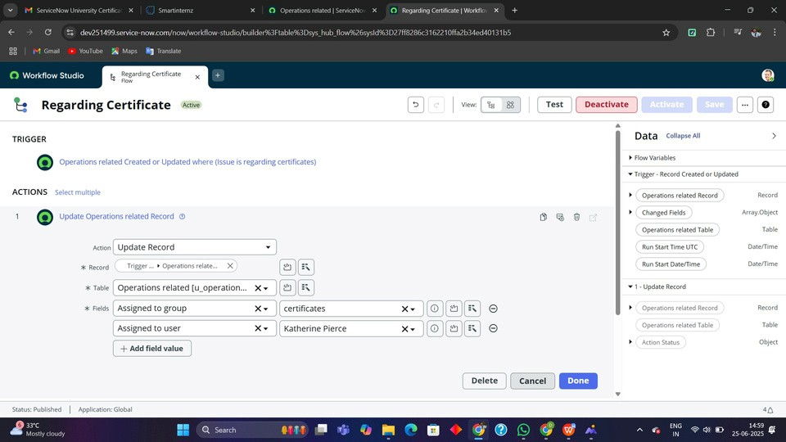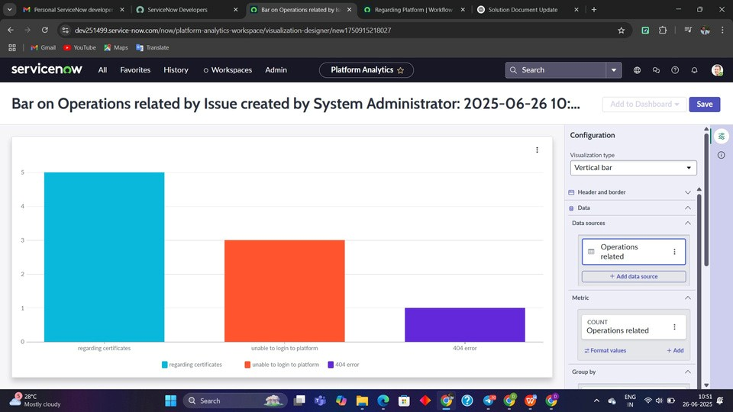

4

. No. of Visualizations / Graphs

:

The dashboard included a total of 3 visual elements: a bar graph showing ticket count by group, a pie

chart for issue distribution, and a line chart representing daily ticket

6

. Story Design

:

Two flows were designed in Flow Designer. One handled tickets with issues related to certificates, while

the other addressed platform-related issues like login problems and 404 errors. Each flow included a

trigger based on record creation or update, conditions to match specific issues, and actions to assign the

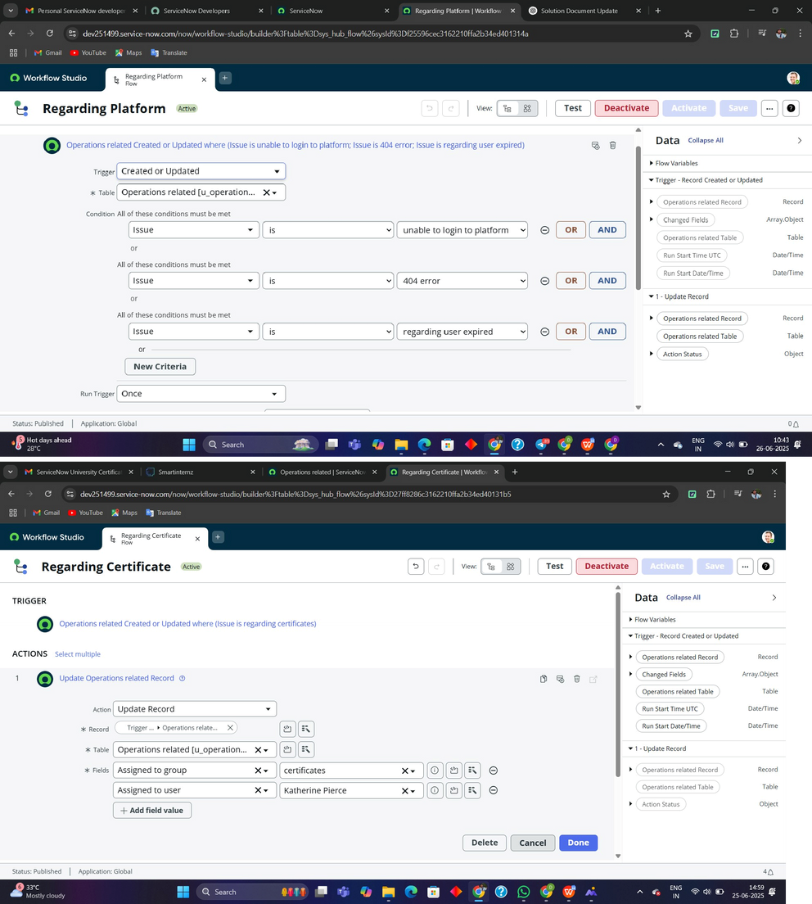

-

All tickets assigned correctly based on issue

ticket to the correct group. The flows were tested and successfully automated the ticket assignment

process, improving operational efficiency.

Results:

|  |
| --- |
| * Unauthorized users restricted from modifying sensitive data * Groups receive only relevant tickets |